

MAJOR PROJECT REPORT

ON

“I-BOT” THE CHATTERBOT

SUBMITTED IN PARTIAL FULFILLMENT OF THE DEGREE

OF

BACHELOR OF TECHNOLOGY

IN

COMPUTER SCIENCE AND ENGINEERING.

Submitted By: Under the Guidance of:Priyanka Bakshi
Name: Kunal Bassi, Shivum Uppal, Vibhor Mahajan Designation: Lecturer
College Roll No.: Y4125, Y4145, Y4156 Department: CSE
University Roll No.: 40503027, 40503048, 40503060

CHANDIGARH-PATIALA NATIONAL HIGHWAY,
VILL.JHANSLA, TEHSIL, RAJPURA,
DISTT. PATIALA 140401

ACKNOWLEDGEMENT

Acknowledgement is not mere formality but a genuine opportunity to thank all those people without that active support in this project would not be able to be possible.
We are thankful to Ms Priyanka Bakshi for their valuable time they devoted to us and give us a lot of knowledge and help regarding our project. During our last semester in the curriculum of B. Tech. we are also thankful to our respected Head of Department Ms Meenu Khurana and teachers for their expert guidance. It is a great experience for us and we gained a lot here.
Words defeat us in expressing our deep sense of gratitude for our class mates, whose continual support and guidance enabled us all the challenges posed by this project, who provided us all the relevant information and the necessary Hardware, Software and new ideas that really helped us a lot. Special thanks are due to all other staff, Colleagues and friends for all the encouragement, inspiration and motivation.
Finally, we are thankful to the almighty God who had given us the power, good sense and confidence to complete my project successfully. We also thank our parents who were a constant source of encouragement. Their moral was indispensable.

Kunal Bassi Signature
Shivum Uppal (Mrs Priyanka Bakshi)
Vibhor Mahajan
PREFACE

The purpose of this report is to assemble under one cover a sufficient body of knowledge about management and developing a successful software engineering project. The following quotes outline the basic idea behind this technical report. This report assembles various functions like planning, organizing, designing, testing, and maintenance of the software developed during the Last Semester.
It serves the purpose of elaborating the analysis and the implementation phases of the above mentioned project. All the features that have been included in the final implementation have been clearly explained to make the project easy to understand. It has been taken care that this document elicits the system development process in a clear and well documented manner.
Its about the adaptation of the techniques of project development and reflects the practice and methods of software engineering project. This report is intended for:
• Project managers—The report delivers the necessary information of the process a software development project
• Project coordinators —The tutorial presents the state of the practice in software development and management techniques.

In the beginning we have provided an abstract into the general features of the project. As we proceed we delve into more intricate details regarding the working of the project.

CONTENTS

S. No. | Contents | Page No.
1. | Introduction to Assigned Project | 5
2. | Modular description of the Project | 9
3. | Detailed Analysis of individual module | 26
4. | Future Prospects | 43
5. | Industry Application | 44
6. | Conclusion | 45
7. | Bibliography | 46
8. | References | 47

Introduction
to
Project
- INTRODUCTION TO ASSIGNED PROJECT

1.1 Objective:
To build a Chatter-bot based on Artificial Intelligence (AI).

1.2 Reasons For Undertaking This Project
- All the present chatter-bots were usually from foreign programmers. No Indian programmer had worked on this. So we wanted to release an Indian version of chatter-bot.
- Everyone is fantasized as to how a computer can be made to generate responses to normal conversation. Such thoughts had even surprised us in our childhood. So the fantasizing outlook towards such project was a major motivating factor in taking this project.
- This was a challenging project in which we thought we will come across all sort of problems and will be able to develop our Java skills to the fullest.

1.3 System Perspective:
iBot is an AI Program that simulates an Virtual Character. The first program of this sort was developed in 1967 in MIT. Such programs, which interact with user in simple English language and can simulate a conversation, are known as Chatter-bot.
The various features of the proposed chatter-bot will be:-
- Chatting with the user
- Emoticons display according to emotion
- Learning levels
- Skins
- Reminders
- Help
- Application opener
Software Process Model

Phase A: CONCEPTION PHASE Phase B: DEFINITION PHASE
# Initiation Stage # Project Definition
# Feasibility Stage # System Definition
*User & System requirements

Phase D: OPERATION PHASE Phase C: ACQUSITION PHASE

System Management & # Design Stage
Evaluation # Production stage
*Testing

System System # Implementation Stage
Improvement Termination * Training
* Acceptance Test
* Installation

To Phase A:
Repeat Cycle

The very first step of developing any system is to study the whole existing system this is called the initial study, analysis and feasibility of the project is being done. Analysis is the detailed study of the various operations performed by the system and their relationship within and outside the system. In context to this project although the records are not maintained on the daily basis but the same procedure is repeated each day and everyday. Hence the need for the computerization is necessary to make the work easier and more comfortable.

The feasibility study is carried out to select the best process that meets the performance requirements. This entails identification, description and evaluation of the candidate process and the selection of the best candidate process for the job. Now according to this project the analysis is to have the complete knowledge about how the software that is going to develop is going to function. From where is the input going to come and what will be the output vs. what is the required output. Once analysis is done or completed the analyst has the firm knowledge of what is to be done. The next step is to decide how the problem might be solved. Thus, in systems design, we move from the logical to the physical aspects of the life cycle.
MODULAR DESCRIPTION OF PROJECT

Programming a Chatterbot requires knowledge of two domains:
  - Artificial Intelligence
  - Natural Language Processing

iBot can not, of course, think on its own. It has a repository or database of facts and rules, which are searched to give the best possible response. iBot works by matching process. Very rarely an entire sentence is matched to give the response. The rules are indexed by keywords. Some rules require no keyword

The basic elements that you will be interfacing with in the creation of a iBot personality are:

Emotion: iBot has an active emotional life. Most of this is built into the AI Engine and so most Keyphrases have Emotion set to 0, but if iBot has particular likes or dislikes, then we can adjust their emotional reaction to any situation.

Keyphrases: Keyphrases are series of words that iBot will recognize. The iBot will search through the text of a message sent to them and will locate these Keyphrases.

Response: Finally, there are Responses. There is a set of possible Responses for each Keyphrase we have. When iBot determines the most important Keyphrase, it will randomly select one of the corresponding Responses. This randomness is designed to prevent repetition. It is good to have several responses for each Keyphrase, for that increases the unpredictability of iBot's Personality.

FEASIBILITY ANALYSIS

Feasibility study describes and evaluates candidate systems and provides for the selection of the best candidate system that meets the system performance requirements. Three key considerations are involved in the feasibility analysis:-
- Economic feasibility
- Technical
- Behavioral

Economic Feasibility
Economic feasibility determines the benefits and saving that are expected from the system and compare them with costs. The main aim of economic feasibility is to check whether the system is financially affordable or not. The cost for the proposed system can be divided into two parts given below:
Hardware Costs
The hardware cost for the proposed system can be calculated from cost of hardware needed for the development of the proposed system. The hardware specifications for the system are given below:-
Personal Computer: The cost of the PC depends upon the configuration of the PC. The minimum specification assumed for the Pc is given below:
- Pentium IV processor
- 128 MB RAM
- 40 GB free disk space
Software Costs: the Software costs for the proposed system can be calculated from the cost of software tools needed from the development of the proposed system. The software tools needed for the development of the system are given below:-
- JDK 1.6

- Technical Feasibility
Technical Feasibility centers on the existing system and to what extent it can support the proposed system. In this part of feasibility analysis we determined the technical possibilities for the implementation of the system. Two major benefits are:
- Improving the performance
- Minimizing the cost of processing
The performance category emphasizes improvements in the accuracy and access to the information. It also makes easier to access the system by the authorized users.

3. Behavioral Feasibility:
Behavioral feasibility estimates the reaction of the User staff towards the development of the computerized system. For the successful implementation of any system, the users must be impressed that the new system is for his benefit. So, the behavioral feasibility plays a very important role in the development of new system It reveals that whether the system is acceptable by user or not. If the user does not ready to use it, then it doesn’t matter how best the system is or how much effort you are putting in its development.

PROJECT PLAN

Team Structure
Team is comprising of three members:
- Kunal Bassi
- Shivum Uppal
- Vibhor Mahajan
- Our very able and helpful project guide Mrs. PRIYANKA BAKSHI

Development Schedule
The work in developing the new system commented immediately with our first meeting with the management and users thereafter we were in continuous touch with the management and users

Programming Languages and Development tools:
The programming language and development tools are the critical factors in the functioning of the developed system, so proper attention has to be paid while selecting these tools. Following are the minimum requirements for installation and making use of the software package:

Interface Requirements

User Interface: It should be interactive attractive & informative
Hardware Interface: Interact with the server, which contains the database
Software Interface: Connectivity to the server & the database
Communication Interface: Server attachment is necessary.

- User Interface
The package must be user friendly and robust. It must prompt the user with proper message boxes to help them perform various actions and how to precede further the system must respond normally under any in out conditions and display proper message instead of turning up faults and errors.

- Hardware Specification
HARDWARE | SPECIFICATION
CPU | Intel Pentium IV
SPEED | 1.5GHz
RAM | 256 MB
HARD DISK | 40GB
KEYBOARD | 105 Keys

- Software Specifications
Software is a set of program, documents, and procedure, routines associated with computer system. Software is an essential complement to hardware. It is the computer programs which when executed operate the hardware.
The “Chatter-bot” has been developed using the following tools :
- CORE JAVA (as front end)

About the Java Technology

Java is both a programming language and a platform.
The Java Programming Language
The Java programming language is a high-level language that can be characterized by all of the following buzzwords:
- Simple | - Architecture neutral
- Object oriented | - Portable
- Distributed | - High performance
- Interpreted | - Multithreaded
- Robust | - Dynamic
With most programming languages, you either compile or interpret a program so that you can run it on your computer. The Java programming language is unusual in that a program is both compiled and interpreted. With the compiler, first you translate a program into an intermediate language called Java bytecodes —the platform-independent codes interpreted by the interpreter on the Java platform. The interpreter parses and runs each Java bytecode instruction on the computer. Compilation happens just once; interpretation occurs each time the program is executed. The following figure illustrates how this works.
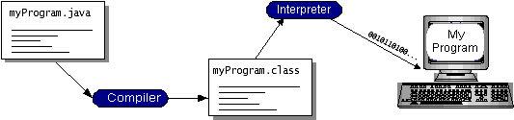
You can think of Java bytecodes as the machine code instructions for the Java Virtual Machine (Java VM). Every Java interpreter, whether it's a development tool or a Web browser that can run applets, is an implementation of the Java VM.
Java bytecodes help make "write once, run anywhere" possible. You can compile your program into bytecodes on any platform that has a Java compiler. The bytecodes can then be run on any implementation of the Java VM. That means that as long as a computer has a Java VM, the same program written in the Java programming language can run on Windows 2000, a Solaris workstation.
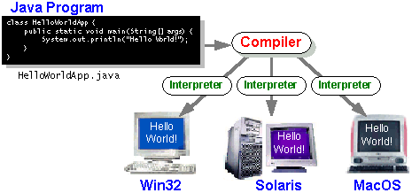

The Java Platform
A platform is the hardware or software environment in which a program runs. We've already mentioned some of the most popular platforms like Windows 2000, Linux, Solaris, and MacOS. Most platforms can be described as a combination of the operating system and hardware. The Java platform differs from most other platforms in that it's a software-only platform that runs on top of other hardware-based platforms.
The Java platform has two components:
- The Java Virtual Machine (Java VM)
- The Java Application Programming Interface (Java API)
You've already been introduced to the Java VM. It's the base for the Java platform and is ported onto various hardware-based platforms.
The Java API is a large collection of ready-made software components that provide many useful capabilities, such as graphical user interface (GUI) widgets. The Java API is grouped into libraries of related classes and interfaces; these libraries are known as packages. The next section highlights what functionality some of the packages in the Java API provide.
The following figure depicts a program that's running on the Java platform. As the figure shows, the Java API and the virtual machine insulate the program from the hardware.
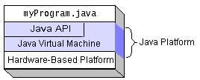

Native code is code that after you compile it, the compiled code runs on a specific hardware platform. As a platform-independent environment, the Java platform can be a bit slower than native code. However, smart compilers, well-tuned interpreters, and just-in-time bytecode compilers can bring performance close to that of native code without threatening portability.

What Can Java Technology Do?
The most common types of programs written in the Java programming language are applets and applications. If you've surfed the Web, you're probably already familiar with applets. An applet is a program that adheres to certain conventions that allow it to run within a Java-enabled browser.
However, the Java programming language is not just for writing cute, entertaining applets for the Web. The general-purpose, high-level Java programming language is also a powerful software platform. Using the generous API, you can write many types of programs.
An application is a standalone program that runs directly on the Java platform. A special kind of application known as a server serves and supports clients on a network. Examples of servers are Web servers, proxy servers, mail servers, and print servers. Another specialized program is a servlet. A servlet can almost be thought of as an applet that runs on the server side. Java Servlets are a popular choice for building interactive web applications, replacing the use of CGI scripts. Servlets are similar to applets in that they are runtime extensions of applications. Instead of working in browsers, though, servlets run within Java Web servers, configuring or tailoring the server.
How does the API support all these kinds of programs? It does so with packages of software components that provides a wide range of functionality. Every full implementation of the Java platform gives you the following features:
- The essentials: Objects, strings, threads, numbers, input and output, data structures, system properties, date and time, and so on.
- Applets: The set of conventions used by applets.

JFC and Swing

JFC and Swing is a part of java extension. JFC is short for Java Foundation Classes, which encompass a group of features to help people build graphical user interfaces (GUIs). The JFC was first announced at the 1997 Java One developer conference and is defined as containing the following features:

- The Swing Components
Include everything from buttons to split panes to tables. Swing. The Swing APIs also provide graphical component (GUI) for use in user interfaces. The Swing APIs are written in the Java programming language without any reliance on code that is specific to the GUI facilities provided by underlying operating system. This allows the Swing GUI components to have a "pluggable" look-and-feel that can be switched while an application is running.

- Pluggable Look and Feel Support
It gives any program that uses Swing components a choice of looks and feels. For example, the same program can use either the Java look and feel or the Windows look and feel. We expect many more look-and-feel packages -- including some that use sound instead of a visual "look" -- to become available from various sources.

- Accessibility API
It enables assistive technologies such as screen readers and Braille displays to get information from the user interface.

- Java 2DTM API (Java 2 Platform only)
It enables developers to easily incorporate high-quality 2D graphics, text, and images in applications and in applets.

- Drag and Drop Support (Java 2 Platform only)
Provides the ability to drag and drop between a Java application and a native application.

- AWT (Abstract Window Toolkit )
The JavaTM platform's Abstract Windowing Toolkit (AWT) provides APIs for constructing user interface components such as menus, buttons, text fields, dialog boxes, checkboxes, and for handling user input through those components. In addition, AWT allows for rendering of simple shapes such as ovals and polygons and enables developers to control the user-interface layout and fonts used by their applications..

JRE and JDK
Sun Microsystems provides two principal software products in the JavaTM Platform, Standard Edition (JavaTM SE) family:

Java SE Runtime Environment (JRE)
The JRE provides the libraries, Java virtual machine, and other components necessary for you to run applets and applications written in the Java programming language. This runtime environment can be redistributed with applications to make them free-standing.

Java SE Development Kit (JDK)
The JDK includes the JRE plus command-line development tools such as compilers and debuggers that are necessary or useful for developing applets and applications.

JAVA VIRTUAL MACHINES
The Java virtual machine is an abstract computing machine that has an instruction set and manipulates memory at run time. The Java virtual machine is ported to different platforms to provide hardware- and operating system-independence.
The AI Base principles
Any dialogue has a beginning and ending, like saying "Hello"-"Hey"-"Good morning"-"Hi, how are you?" etc. We always hear these sentences when two people start talking. There are also other situations that don't need these sentences to begin, like "Excuse me, what is the time?" etc. On the other hand, we hear other sentences like, "I have to go now" - "bye, see you later" - "I'll call you later" - "looking forward to see you," etc. These sentences are usually used at the end of conversations.
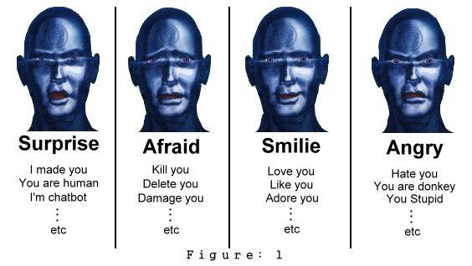
As we can see, there are countless possibilities for inputs that your chatbot may not understand. For this reason, we have to classify any dialogue to a number of subjects and expressions. We also need to create files for each subject and each expression containing all of the related words. Now the chatbot has the database with which to understand user inputs and give suitable outputs. However, it's not entirely accurate because some sentences have similar words but very different meanings.
Example:
"I hate you." This will make your chatbot angry.
"I hate myself." This may also make your chatbot angry, as he is looking for the word "hate." This is wrong because the phrase is does not convey hate towards the chatbot; rather, the user is directing it at himself. So the chatbot should be sad or surprised, not angry.
We must therefore build search engines to look for user inputs in different ways, to make sure that your chatbot will understand user inputs well and give suitable responses. We are going to discuss these search engines, which I call Special Search Engines and Matrix Search Engines.

Special and Matrix Search Engines
The Special Engine compares between sentences stored in the database and user inputs, while the Matrix Engine compares between words stored in the database and user inputs. Each file has two types, Matrix Database and Special Database. Each type of database uses its engine.
File: "Laugh"
...to Special "Laugh" Database
...to Matrix "Laugh" Database
The following example shows the difference between the two engines.
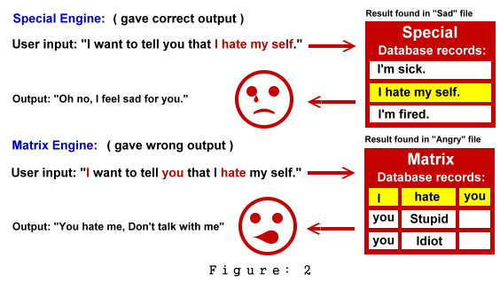
The Matrix Engine failed to give the correct answer because it was looking for words. You may think that the Matrix Engine is useless, but it is actually not. As we had said before, we can't fill the AI Base with all possibilities and so the Matrix Engine is very important to cover more possibilities than the Special Engine.
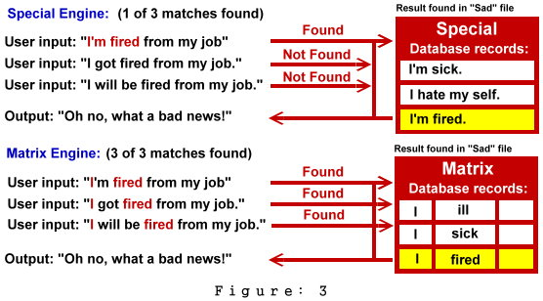
The importance of the Matrix Engine is in understanding three different sentences that have the same meaning. The match is with only one record in the Matrix Database. That means that the Special and Matrix Engines complete each other. One last thing you should know about this engines is that the Special Engine is a part of (belongs to) the Matrix engine and so we should arrange the steps of searching as follows:
- 1st search in: Special Engine. If a result is found, then give the output. Else search using the Matrix Engine.
- 2nd search in: Matrix Engine. If a result is found, then give the output. Else search in the One Word File.

If we follow these steps in searching, we will not face the problem of the Matrix Engine or the problem of the Special Engine. You may wonder what the One Word File is after both the Matrix Engine and the Special Engine failed to find any matches. One Word File is a database that contains only one word that may be found in user inputs. So, our chatbot may reply with something related to the user input, but with less accuracy.

The accuracy of the Special Engine, Matrix Engine and One Word File:
- If the result is found in the Special Database, its accuracy in producing suitable output is roughly 95%.
- If the result is found in the Matrix Database, its accuracy in producing suitable output is roughly 65%.
- If the result is found in the One Word Database, its accuracy in producing suitable output is roughly 15%.

We can increase the accuracy of your chatbot's response by increasing the records of Matrix and Special Databases for each file and One Word Database.

Chatbot response

We will now discuss how the chatbot responds and gives suitable answers depending on user inputs. We will also examine how to make our chatbot gives more than one answer for the same input. This will make our chatbot more real, human-like and more reasonable. Each file has two databases: Special and Matrix. Each database also contains two fields:
- 1st field: "Request" is where the user inputs are compared with data recorded in this field. See Figures 2 and 3.
- 2nd field: "Respond" is where the chatbot outputs are taken from data recorded in this field.

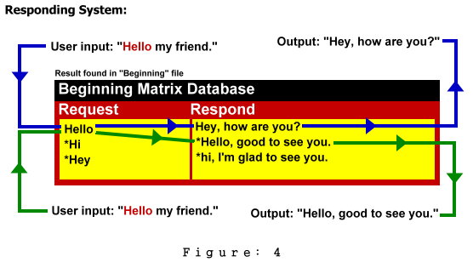
There are two outputs for the same input. Also, one row can contain more than one request and respond value. This decreases the number of records, as it reduces the repeated (related) sentences in one row.

How to make chatbot respond by different ways
To do this, you have to create a variable with an initial value equal one. Every time your chatbot gives a response, add 1 to the variable value. When the Request value matches with the user input, the output equals the sentence that has the number of the variable. If the variable is greater than the last sentence number, make this variable equal to 1 and let the output equal the 1st sentence. Otherwise, add 1 to the variable value.
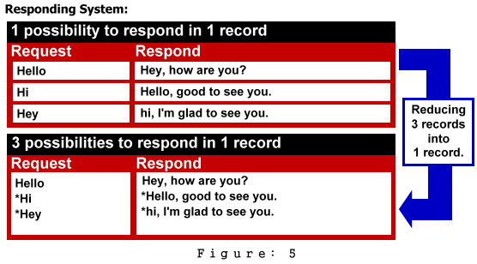
This figure shows how to merge related records into one record. This also leads to merging responses into one record, which makes your chatbot respond in different ways.

Misunderstanding
Assume that, after trying both the Matrix and Special Search Engines, your chatbot didn't find any records similar to the user input. This means that your chatbot can't understand the user input. Perhaps the user mistyped the input or perhaps you simply have poor AI databases. You need to create a database that your chatbot can use to generate sentences about misunderstandings.
Example:

I don't understand.
Please explain.
Also, you can improve the database by inserting sentences that don't refer to understanding or misunderstanding. These sentences leave an impression on the user, as they make your chatbot appear to understand.
Example:

Wait, I got a phone call.

Oh, my keyboard hung again.

Previous Events Engine
When we ask anyone about something and then we ask them about it again, they are going to say, "I told you that …etc." That means that his/her mind recorded a previous conversation about the same subject and that made him/her say this sentence. The Previous Events Engine function simulates the same thing with the chatbot.
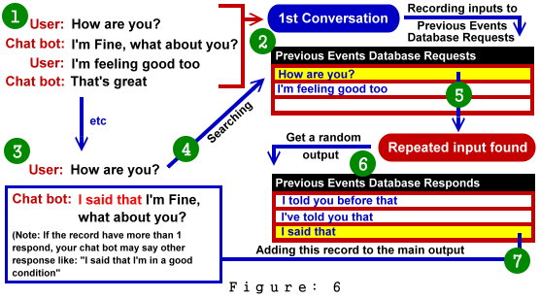
This shows how the Previous Events Engine works. We may notice that there are two databases for this engine: the Request Database, which records user inputs if there is no repeated input, and the Respond Database, from which your chatbot gets a random sentence that expresses a repeated input.

Reminders and notifications
To put this feature into the chatbot, one should create a database that contains all of the events that happen on a specific date, time or date and time in the records. After creating this database, make the chatbot always check the current time and date and compare it with the records in the database. If the current time, date or both equals one of the records then the chatbot should say what is recorded in the matched records.
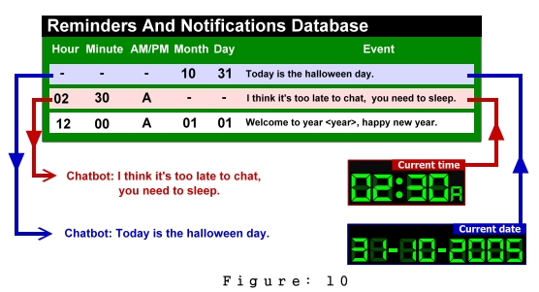
SCREENSHOTS
This is the first screen that is encountered as we run the program. It is an entry form which ask the user about the user name to be inputted. If no name is entered then an message box will appear showing that an null name cant be accepted in this.

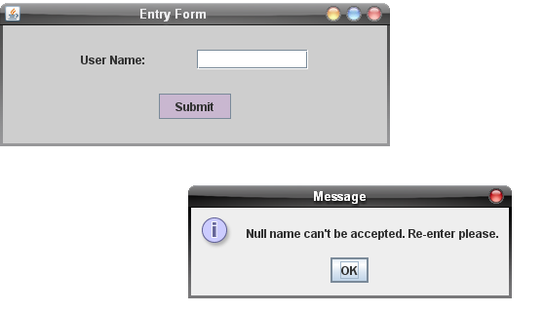

Thus we approach to next stage by entering the user name. This username will be displayed when the user will chat with the chatbot later.

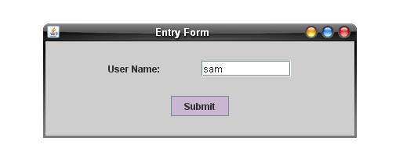

Here the program starts loading and this screen is presented to the user.
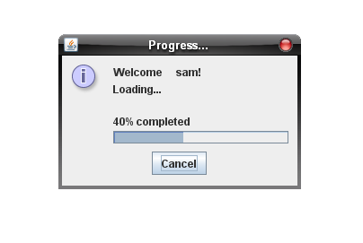

Chat screen
This is the basic chat screen which shows the user and iBot conversation.

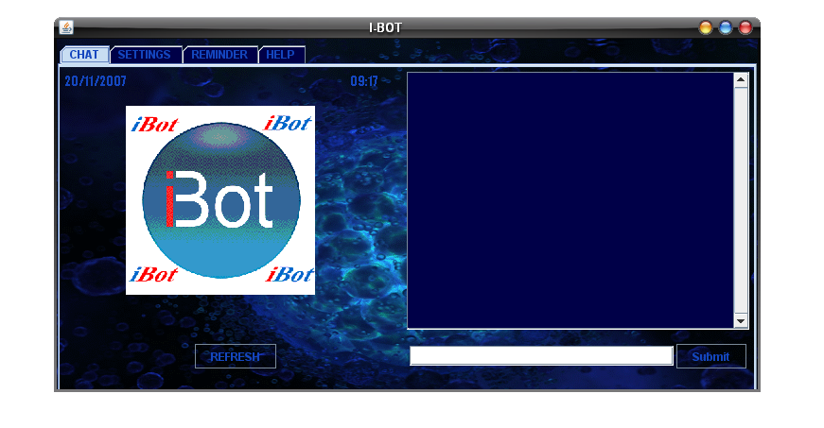

This is what it looks like when the chat has been initiated. Here on the left side panel, we have emoticons displayed according to the mood of the user or the chat going on between the chatbot and the user.

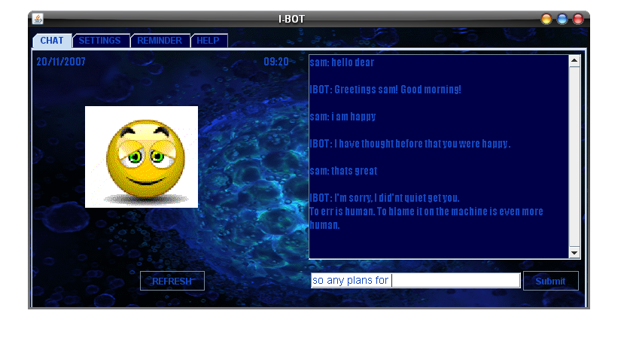

The settings screen which has the user neme change option, learning level bar, and the skins changing option.

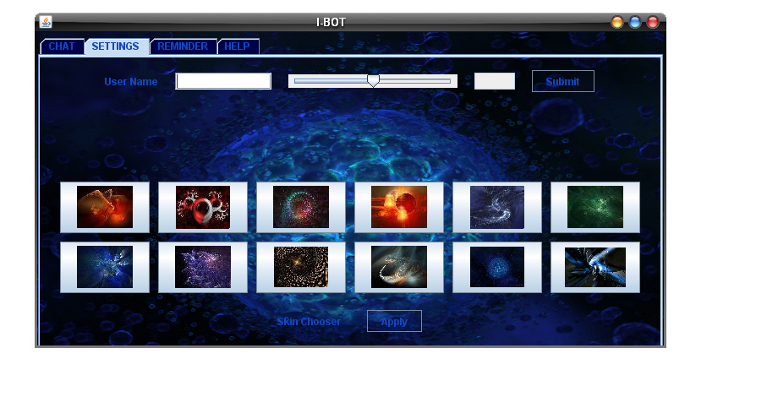

The reminder screen

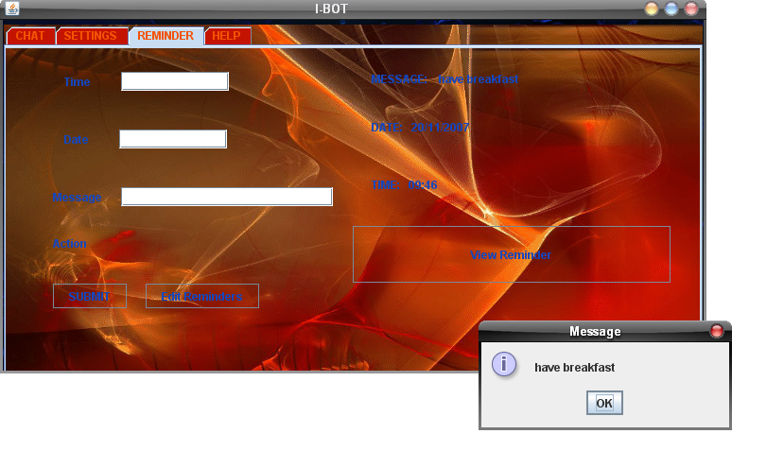

Help

DETAILED ANALYSIS OF THE PROJECT

iBRAIN

The brain module of iBot is from where iBot derives its intelligence. Programming of the brain required a very basic understanding of how human brain processes natural language and generates a response to input.
After studying some theories, what I’ve understood about the functioning of human brain and its natural language processing, I drew the following conclusions:
- The human brain has a repository of a huge vocabulary. The fascinating thing about the vocabulary is that we cannot think about something or understand it if we don’t have words to describe it. Like we cannot describe pain without some word present in our vocabulary to describe it.
- We accumulate a large storage of commonly used sentences and their corresponding responses over a large period of time in our lives by studying in school, conversing regularly with other human beings etc.
- We rarely invent new sentences while conversing with other people. Rather, most of the sentences we use are picked up from our memory and used as it is or with slight modifications.
- Natural languages are ambiguous and our understanding of sentences in a conversation comes mostly from observing the body language and tonality of the other person rather than from words used in the sentence. Like we can difference between teasing and insult only by the tonality of voice used while speaking.
- People are fascinated by the idea of chatting with a computer and paying attention to small details like pointing out gibberish by user makes a lasting impact on the user.
- Good conversations contain more questions than sentences.
- People get bored when the responses are predictable. Random responses and counter-intuitive stimulates the brain.
- Humans love to listen to their own name being called out. So it’s a good thing to make the responses personal by addressing the user by name.

The objectives and functions of brain module are:
- Process the user input as Standard English language.
  - Format the input to remove noise. For example, multiple punctuation marks as in “Hi!!!” are to be corrected into “Hi!”
  - Change the frame of reference from user to iBot. I have regarded iBot as an individual who has her own perspective and knowledge of self. So when we ask “How are you?” iBot sees it as “How am I?”
  - Draw out meaningful conclusions about the user input by looking for standard keywords and specific parts of the input.
  - Change the emotional state of iBot dynamically based both on the user input and a random variable.
  - Maintain a repository of classified common vocabulary to match patterns and keywords.

- Generate the best fit response corresponding to the user input.
The brain maintains a huge database of responses. The response is chosen in two ways-
  - If the user input matches exactly with pre-defined commonly used sentences then iBot can generate very accurate and apt responses. The common sentences are like “Hi!”, “How are you?”, “What is your name?” etc.
  - If there is no exact fit for the user sentence in memory, then iBot searches the sentence for a common pattern. The responses generated are very general but have a high degree of accuracy. Like if user enters- “I love music” or “I love to watch cricket”, the response generated will be similar but intelligent and suitable.
  - If no pattern exists for the user input and the user input is a statement, then the iBot’s brain tries to intelligently reframe the sentence into something meaningful like if user says that “Vibhor is a good boy”, iBot might generate a statement that “Oh, Vibhor is definitely a good boy .”
  - If the user has asked an unknown question, iBot prompts the user to give a suitable answer for his own question so that iBot’s remembers it the next time and grows more intelligent.
  - iBot’s brain has an ability to store statements and make connections between them. It can then make deductions based on these stored statements. Like if user says “If it rains then carry an umbrella”. Then user says “If you carry an umbrella then you might get struck by lightening”. Now if user says “It rains” then iBot might respond as “You might get struck by lightening”.
  - If the input is still not understandable by iBot then it might be that there is a typing error and iBot conveys this to the user.
  - iBot’s brain generates responses to misc inputs like a null input or gibberish.

- Perform user assistance tasks
  - iBot’s brain understands user request to set a reminder and stores it in its data store. These reminders are user specific and are displayed as and when time comes.
  - Open common windows applications like notepad, calculator etc. by giving commands in natural language.

IBOT GUI :

I-Bot, the dynamic chatterbot has exciting graphical features, all bind together in one frame.

The frame contains one major panel called JTabbedPane which is responsible for making four tabs. These tabs are as follows:
1. Chat Tab
- Settings Tab
- Reminders Tab
- Help Tab

We will discuss each tab in detail with its functioning and its respective features.
This is how our major front screen looks like.

CHAT TAB

Here in this tab, we have divided the whole screen into two equal parts:-
- The animation part
- The conversation part

Animation Part
Here we have implemented some of the important features of chatting in a JPanel. The layout manager decides the actual look of the objects. The objects inserted in this panel are:
- A dynamic clock
- Current system date
- Emoticons
- A ‘Refresh’ button

The dynamic clock:- This displays the current system time. It is accesed by using a Timer class which is in built. It communicates with the system clock and as per that, the clock is dynamic. It can be set to various formats like AM|PM, HH:MM:SS etc.

Current system date:- This displays the current system date on the panel. It can also have various formats.

Emoticons:- This is one of the exciting features of I-BOT, in which the I-BOT will communicate with the user through facial emotions also. For example, if he is sad, he will display a “sad” emoticon. And likewise there are many emoticons stored in its memory. This enhances the aesthetic look of the I-BOT.

‘Refresh’ button:- Suppose the I-BOT is angry, so it will display an “angry” emoticon and it will carry on till the user click the “refresh” button. This is applied so as to avoid the display of irritating animations again and again. As soon as the user clicks the ‘refresh’ button, it will display the original I-BOT logo.

Conversation part

This is the second half of the original screen where the actual conversation between the user and the I-BOT is going on. This panel is further divided into a JScrollPane, which creates a scroll bar, both vertical and horizontal. Following are the objects inserted in this panel:-
- Scroll bar
- Text Field
- ‘Submit’ button

Scroll bar: The scroll bar is used in order to avoid any problems in viewing the earlier lines. As the lines of conversation keeps on increasing the text automatically starts scrolling up so as to view the present lines of chat.

Text Field: It is the text area where the user inputs the string or set of strings.

‘Submit’ button: This button is used to enter the input string in the chat conversation area. When the user has written the data, he will press the button ‘submit’ and the data will be entered. Instead of pressing ‘submit’ he can also directly press the ‘enter’ key.

SETTINGS TAB

This tab is created for any kind of editions in the I-BOT. editions like, change in user name, change in the learning level of the I-BOT and changes in the back ground images of the I-BOT. Its features are:
- Changing user name.
- Learning level slider bar
- Skins

Changing user name: The user name can be changed from this panel. Here the name that is changed will replace the previous name.

Learning level slider bar: The I-BOT has discrete learning levels as per which he learns. When the learning level is set to 100, it will learn everything, i.e. the probability of learning is full.

Skins: There are many inbuilt skins which makes I-BOT much more aesthetic. With the change in background image, the buttons, the text color, the static look is washed away, thus appealing more to the user. These are shown as thumbnails, when one is clicked and ‘Apply’ button is clicked, the skin is applied.

The Setting tab is divided into 3 panels.
First Panel contains the user name area, the slider bar which sets the learning level and a ‘submit’ button. Whereas the Second Panel contains the various thumbnails of various skins that have been embedded into it. Actually, there are 12 skins so, we have put 6 thumbnails in one row. Now comes the Third Panel, it contains a final ‘Apply’ button, which when clicked, activates the selected skin on the I-BOT.
REMINDER TAB

This is the place where the dynamic and runtime reminders are set for the user. This is basically an alarm system but with a message at a particular time. The user sets up the reminder at a particular time and the message pops up, when the right time comes.

This tab is divided into two halves:-
- Settings part
- Display part

Settings Part
The settings part is used to implement the settings of the reminder like date, time, message etc. Here the time, date and the text message are saved into the I-BOT memory so that it can pop up the message when it’s the time. It has following components:-
- Date Field
- Time Field
- Text Message Field
- Submit button

Date Field receives the date from the user in the format of DD/MM/YYYY. The I-BOT saves this date in its memory but before saving it will check if the format is correct or not, if not, it won’t save it. It also won’t save the dates before the present day.

Time Field receives the time from the user in the format of HH:MM:SS. The I-BOT saves this time in its memory but checks the format before saving.

Text Message Field receives the text message from the user for which the user wants to be reminded about. This message length is defined in the I-BOT memory.

Submit Button submits he whole data that is taken from the user into the I-BOT’s memory. If any field is left empty then after clicking ‘Submit’ it will give an exception and will ask the user to re-enter the empty field.

Display Part
Over here, in this segment of Reminder Tab, the whole reminder is displayed for the user’s information. As soon as the ‘Submit’ button is clicked, the whole data as a text is displayed on the right side of the window, thus helping the user to cross check all the data that he has input. He can thereby, check the time, date and the message.

HELP TAB

This is the last tab of the window which contains:
- FAQ
- General tips
- Software’s Version

FAQ are the Frequently Asked Questions which a novice user always has in his\her mind while dealing with any software. Here we support help to the user with any kind of assistance he\she needs.

General tips are also sometimes helpful to the user.
They can be like, friendly behavior with the I-BOT, not being rude, because if the I-BOT feels that the user is being rude, he will straight away insult the user.
The user should also be aware of the fact that the I-BOT is always ready to learn new things from new users, so the user can teach him some new things by setting the “Learning Level” in the “Settings Tab” to 100.
Rest all is up to the user how he enjoys chatting with our Intelligent-BOT.

Software Version of our I-BOT is V1.07.

MODULAR DESCRIPTION OF ANALYSIS PHASE

A complete specification of the software is the 1st step is the analysis of system. Requirements analysis provides the designer with the representation of functions and procedures that can be translated into data, architecture and procedural design.

EXISTING SYSTEM
- All the present chatter-bots were usually from foreign programmers. No Indian programmer had worked on this.

PROPOSED SYSTEM
The various features of the proposed chatter-bot will be:-
- Chatting with the user
- Emoticons display according to emotion
- Learning levels
- Skins
- Reminders
- Help
- Application opener

The goal of requirement analysis is to find out how the current system is working and if there are any areas where improvement is necessary and possible. This may result in using alternative ways to data storing and processing.

Developing Environment:
The development environment is the critical factor in the functioning of the developed system, so proper attention has to be paid while selecting this environment. Following are the tools, which are used in developing software package:

Phases Involved in the development of the system
- Identify needs and benefits
  - Studied and identified the existing system.
  - Identify needs and project constraints
  - Established project statements

- Prepared a detailed report of the existing system at work.
  - Prepare the software requirement specifications .
  - Actual coding started.

Operating Environments:
The proposed project will operate under the following specification
Hardware Required:
Processor: Pentium Processor
RAM: 256MB
HARD DISK: 40GB

Software Required:

O.S.: Platform independent
Language: JAVA

STRUCTURED ANALYSIS

Structured analysis is a set of techniques and graphical tools that allow the analyst to develop the new kind of system specifications that are easily understandable to the user. Analyst works primarily with their wits, pencil, and paper. The traditional approach focuses on cost/benefit and feasibility analysis, project management, hardware and software selection, and personnel considerations. In contrast, structured analysis considers new goals and structured tools for analysis. The new goals are the following:

- Use graphics wherever possible to help communicate better with the user.
- Differentiate between logical and physical systems.
- Build a logical system model to familiarize the user with system.

The structured tool focus on the tools listed earlier-essentially the data flow diagram, data dictionary, structured English, decision tree and decision tables. The objective is to build new document, called system specifications. The document provides the basis for design and implementation.
The primary steps are:

- Study affected user areas, resulting in a physical DFD. The logical equivalent of present system resulting in logical DFD.
- Remove the physical checkpoints and replace them with logical equivalent.
- The software should be general in nature so that easy modifications and enhancements should be made.
- The documentation was strictly done during the entire effort of the system development. This was to allow the system design as well as code to be easily understood by future developers.

MODULAR DESCRIPTION OF ANALSIS AND DESIGN PHASE
In this phase, the software development process, the software's overall structure and its nuances are defined. In terms of the client/server technology, the number of tiers needed for the package architecture, the database design, the data structure design etc are all defined in this phase. A software development model is created. Analysis and Design are very crucial in the whole development cycle. Any glitch in the design phase could be very expensive to solve in the later stage of the software development. Much care is taken during this phase. The logical system of the product is developed in this phase.
The High Level Design

In this phase, we have decided how the application should function. The formats for data input and data output re finalized here. The functional specifications documentation of the application is presented in a language that can be understood all. The finished project design is, however, executed on the approval.

Features of the Design phase

- User friendly
- Fast results using the automated catalogue.
MODULAR DESCRIPTION OF CODE GENERATION PHASE
The design must be translated into a machine-readable form. The code generation step performs this task. If the design is performed in a detailed manner, code generation can be accomplished without much complication. Programming tools like Compilers, Interpreters, and Debuggers are used to generate the code. Different high level programming languages like C, C++, Pascal, and Java are used for coding. With respect to the type of application, the right programming language is chosen.
In our Project we use JAVA language as it overcomes so many limitations of C and C++.

MODULAR DESCRIPTION OF TESTING PHASE
Once the code is generated, the software program testing begins. Different testing methodologies are available to unravel the bugs that were committed during the previous phases. Different testing tools and methodologies are already available. Some companies build their own testing tools that are tailor made for their own development operations. Testing is vital to the success of the system. System testing makes a logical assumption that if all the parts of the systems are correct, the goal will be successfully achieved. Inadequate testing leads to errors that may not appear until months later. This creates two problems.
- The time lag between the cause and the appearance of the problem.
- The effect of system errors on files and records within the system
A small system error can conceivably explode into a much larger problem. Effective testing early in the process translates directly into long-term cost savings from a reduced number of errors.
Another reason for system testing is its utility as a user-oriented vehicle before implementation. The best program is worthless if it does not meet the user needs. Unfortunately, the user’s demands are often compromised by efforts to facilitate program or design efficiency in terms of processing time or memory utilization. Often the computer technician and the user have communication barriers due to different backgrounds, interests, priorities and perhaps languages. The system tester (designer, programmer or user) who has developed some computer mastery can bridge this barrier

Testing Techniques

Both the Black Box testing and White Box testing techniques will be applied to the proposed project for validating the software interface and to selectively ensure that the internal working of the software is correct. The input will be validated so that the correct output is produced. The checks for consistence of the database will be properly evaluated. The procedure of the system will be highly checked for the logical paths and for specific set of conditions, loops etc.

1. All the paths within module will be exercised at least once
2. The logical decision will be exercised for true or false sides
3. Whole code will be verified for the syntax errors
4. The internal data structure will be validated for data consistency
5. The graphical user interface will be checked for particular event
6. The complete application will be tested after the integration of all modules and sub modules

Testing Strategies
Unit testing will be applied to all the modules of the project. All the modules of the project will be tested with White Box and Black Box testing to complete unit testing. Integration Testing will also be applied to verify that all the interfaces work in co-ordination with each other. The Data Flow between different modules will be verified for the consistency of the system. The Bottom Up approach of integration will be applied to the proposed project. The alpha testing of the project has been done by the team members. The beta testing will be done by the some other known Java professionals

PROCEDURE FOR IMPLEMENTATION

System Test Documentation
Documentation
Implementation Plan

Plan
Conversion portion of Implementation plan

Implementation plan

Project Plan
Perform file Conversion
Conversion
Implementation documentation
Prepare plan for post-implementation
Complete conversion

Perform parallel processing

Log results of Conversion
Conversion

Any Discrepancies?

Discrepancies?
Diagnose and
Correct discrepancies

Discontinue parallel processing
Implementation results

ACCEPTANCE PHASE

In this phase, based on the pre-defined acceptance criteria, we have conducted acceptance testing for the project. In the case the acceptance criteria are the fulfillment of all the requirements identified during the requirement analysis phase.

The project is currently under alpha phase of Acceptance testing.
The messages generated for program exceptions are deliberately kept non-user friendly for easier debugging. iBot gets more and more intelligent with time by chatting with users. iBot project is open to user feedback and suggestions. As more common sentence patterns are identified, they are easily incorporated into the project.

MAINTENANCE PHASE
Software will definitely undergo change once it is delivered . There are many reasons for the change. Change could happen because of some unexpected input values into the system. In addition, the changes in the system could directly affect the software operations. The software should be developed to accommodate changes that could happen during the post implementation period.

FUTURE PROSPECTS:

- Identification of slangs and “sms type language” like “hw r u?” can be made understandable.
- Incorporating more common sentence patterns and corresponding responses.
- There is a huge scope of improvement in the emotional state management.
- Learning by Time or Experience can be Implemented.
- ll the previous talking can be stored in a array of strings, so that in case of user contradicting himself/herself, iBot can contradict him.
- Sessions and User-Password Pairs can be established, so that, even after the completion of one session, next time, whenever the user enters his User Name and Password, iBot, will get all the relevant data and previous talks, related to the user, from the database itself.
- A prospect for the cache Memory can be made, so as make the retrieval of data and information can be faster.
- Vast area of research is just waiting to be exploited under the subject of NLP. Like the new field of Chomsky grammar can be implemented thus improving the response quality and providing elegance to chatterBots.

APPLICATION

This software does not require high configure system . It can efficiently run on any system without any error. It can find application in
- robotics
- defense
- business application as a personal assistance
- basic recreation purpose.
CONCLUSION

This project that we undertook was truly a very rewarding experience for us in more than one way. It has given a big thrust to our technical knowledge as prospective Software professional. It has also helped us enhance our skills on the personal front. We feel extremely satisfied by the fact that we have managed to develop the project of course with equal contribution. We think we have exploited the opportunity that came our way to the fullest extent by increasing my technical know-how and also gaining the valuable work experience apart from studying the other subjects in our curriculum.

We gained an insight into the working of the web-based systems. This was even more rewarding as it was a typical real world situation.
BIBLIOGRAPHY

The following books are being used to fulfill the requirements of the proposed project and are helpful in the understanding, development and the maintenance of the project:

- Software Engineering Roger S. Pressman
- Java K.A.Mugal
- Java 2--Complete Reference (5th Ed 2002) Osborne

REFERENCES

Websites visited:
- http://www.dmoz.org/Computers/Artificial_Intelligence/Natural_Language/Chatterbots//
- http://www.simonlaven.com/
- http://www.geocities.com/brizglace
- http://www.chatbothub.com/
- https://secure.wikimedia.org/wikipedia/en/wiki/List_of_Chatterbots
- https://secure.wikimedia.org/wikipedia/en/wiki/Chatterbot

